Received in the IMAGE Office on 5/7/2020

FOOD DISTRIBUTION FOR OLDER ADULTS
Baltimore County Executive Johnny Olszewski announced that, beginning next week, the Baltimore County Department of Aging will be expanding its food distribution efforts by providing boxes of food for older adults. The program will be supported by $590,000 in funding thought the federal Families First Coronovirus Response Act (FFCRA) to specifically target individuals 60 and older.
Under this new program, each box of food will include three meals and a snack for six days. When combined according to the directions, each meal meets the nutritional requirements for adults age 60 and older.
Boxes will be distributed BY APPOINTMENT ONLY at three senior center locations in three different regions of the County.
Baltimore County residents over 60 years of age should call 410-887-2040 to schedule their pick-up time, date and location. During the appointment, individuals will be asked to show proof of age through their BCDA Senior Center Card or other identification.
Anyone unable to travel to these locations should contact Maryland Access Point (MAP) at 410-887-2594 to discuss other food options with our staff.

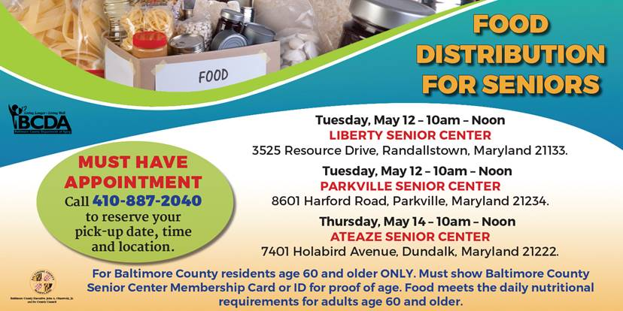

Photo says: Food Distribution for Seniors
Must have appointment. Call 410-887-2040 to reserve your pick up date, time, and location.
Tuesday, May 12 10 a.m. to noon at Liberty Senior Center 3525 Resource Drive Randallstown, MD 21133
Tuesday, May 12 10 a.m. to noon at Parkville Senior Center 8601 Harford Rd Parkville, MD 21234
Thursday, May 14 10 a.m. to noon at Ateaze Senior Center 7401 Holabird Ave Dundalk, MD 21222

For Baltimore County Residents age 60 and older ONLY. Must show Baltimore County Senior Center Membership Card or ID for proof of age. Food meets the daily nutritional requirements for adults age 60 and older.

